General Additive Model of White Fir in USA
Preston Heen
3/2/2020
Introduction
A general additive model can be used to make predictions when predictor variables are more complex. The areas of interest were plots of white fir (Abies concolor) that were measured around the United States. Predictor variables that were used was wind, rain, minimum temperature, and solar radiation. The goal is to find the spatial variation of the height of white fir.
Methods
I wanted to create a model that predicted the height of white fir in the United States. I downloaded point data from the Forest Inventory and Analysis program. Each point was a plot of trees, and included the maximum height. The maximum height was used as the response variable.
The predictor variables were wind, rain, minimum temperature, and solar radiation. I extracted the values of the predictor variable to the point data, using ArcGIS Pro. In RStudio I ran a generalized additive model using these variables, and changing the gamma value as a smoothing factor. In Bluespray, I used a raster of the United States to make a point shapefile, and made the predicted point shapefile a raster. Then I extracted the values of the prediction to the point shapefile, and interpolated the points to create a predicted model map.

Table 1. Model runs, predictor variables, and model parameters
Model Run | Independent Variable | Model Parameters
1a | Wind, rain | Gamma=1.4
1b | Wind, rain | Gamma=10
1c | Wind, rain | Gamma=20
2a | Wind, rain. min temp | Gamma=1.4
2b | Wind, rain, min temp | Gamma=10
2c | Wind, rain, min temp | Gamma=20
3a | Wind, rain, min temp. solar radiation | Gamma=1.4
3b | Wind, rain, min temp. solar radiation | Gamma=10
3c | Wind, rain, min temp. solar radiation | Gamma=20

Results
The best model that was run was Model 3a, and we can see that it has the lowest AIC value(Table 2). The predicted maximum height was 141.63 feet. The deviance explained is also shown in the table, and model 3a has the highest percentage. The response curves for each predictor variable are included as well. I created a map as well, and it shows the height of white fir in the United States.
Table 2. Model comparison of the AIC value
Model Run | AIC Value | Deviance Explained
1a | 61,657.22 | 10.8%
1b | 61,757.70 | 9.01%
1c | 61,856.20 | 7.41%
2a | 61,635.12 | 11.2%
2b | 61,769.88 | 8.82%
2c | 61,842.97 | 7.65%
3a | 61,443.31 | 14.2%
3b | 61,560.06 | 12.2%
3c | 61,732.51 | 9.44%

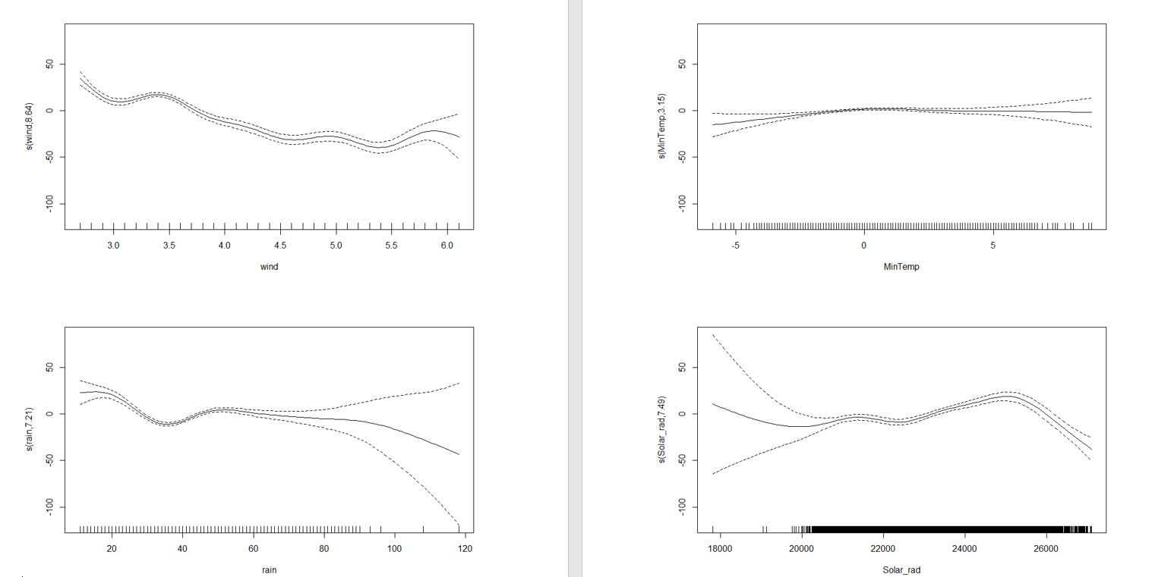
Figure 1. Response curves of predictor variables: Wind (Top Left), Minimum Temperature(Top Right), Rain(Bottom Left), and Solar Radiation(Bottom Right)

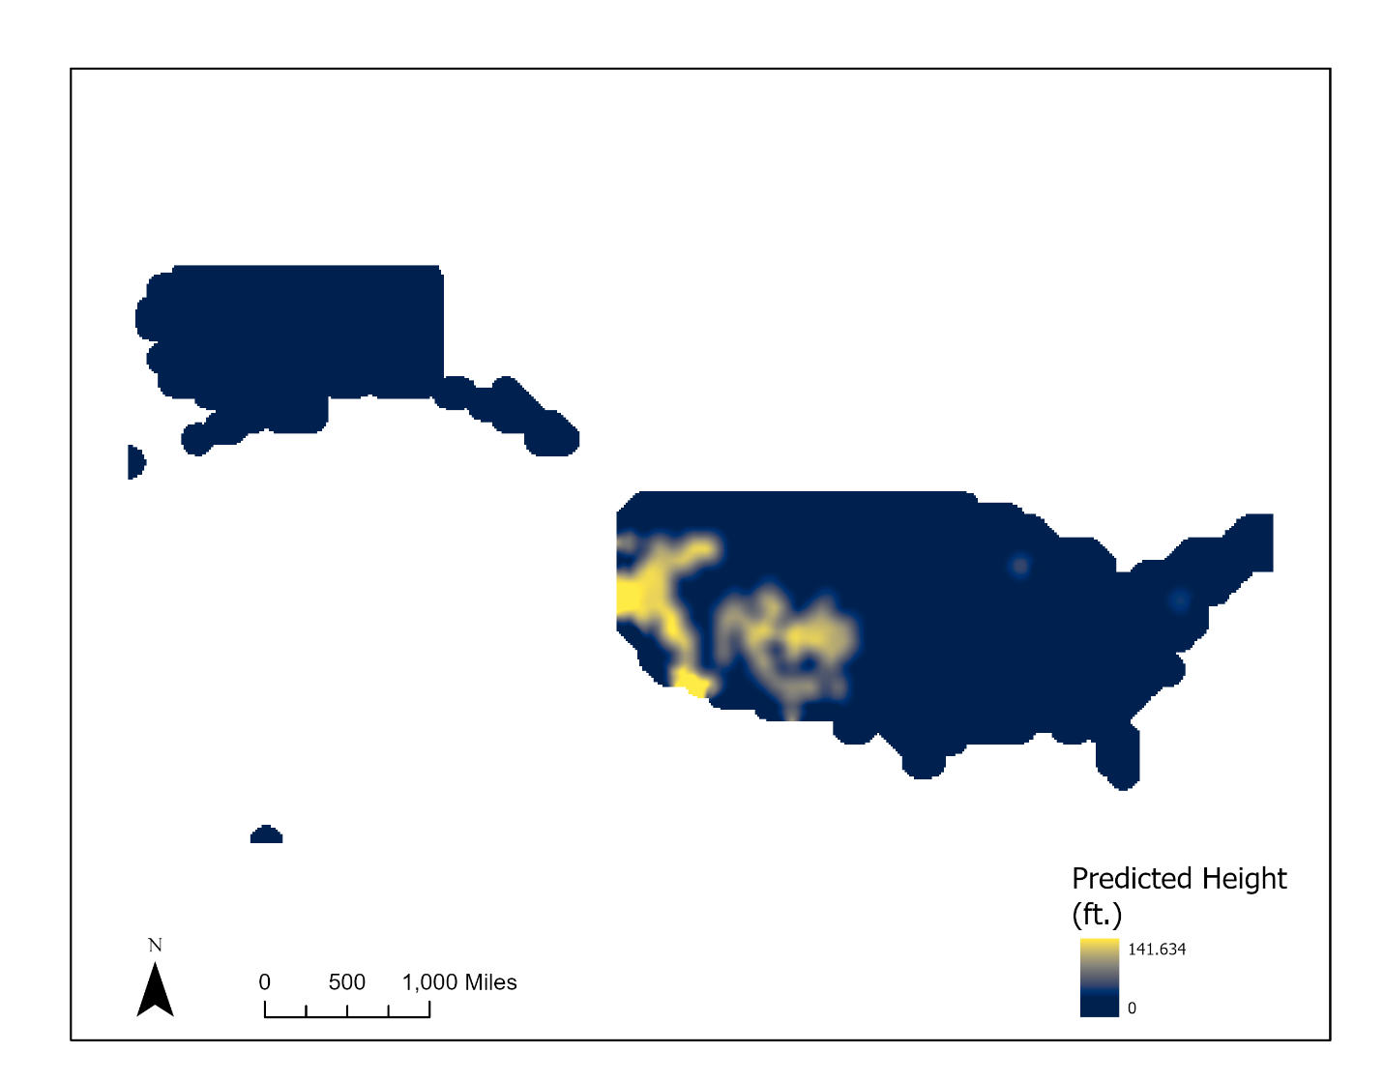
Figure 2. Predicted height of white fir across United States.

Discussion
In the model the higher I raised my gamma, the AIC would increase also. This model did not have any validation, just comparison of models. Using these predictor values, I believe it did catch the phenomenon of the height of white fir. As I added covariates, then the AIC was lowered, and the explained deviance increased. Model 3a is the best model run, because the AIC is lowest, and the explained deviance is the highest.

Acknowledgements
I would like to thank the Forest Inventory and Analysis program, and WorldClim.org for having free data available to download.

Appendix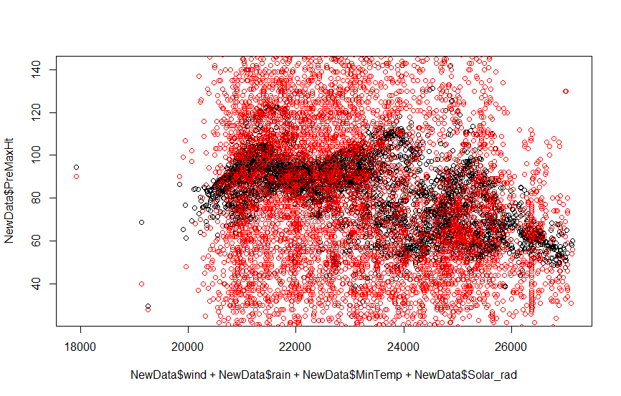
Figure A. Model 3a prediction (black) and original data(red)

